1. SELECT **concat**(customer_first_name," ", customer_last_name) as full_name, * FROM `scaler-ds-ml-de.farmers_market.customer` limit 10
2. SELECT **upper**(concat(customer_first_name," ", customer_last_name)) as full_name, * FROM `scaler-ds-ml-de.farmers_market.customer` limit 10
3. SELECT

concat(lower (customer_first_name) ," ", substr(lower(customer_last_name), 1,1))

as full_name, * FROM `scaler-ds-ml-de.farmers_market.customer` limit 10

1. SELECT * from `farmers_market.customer`

where customer_zip=22802

SELECT * from `farmers_market.customer`

where customer_first_name='Bob'

order by customer_id asc

SELECT * from `farmers_market.customer`

where customer_id between 10 and 20

order by customer_id asc

SELECT * from `farmers_market.customer`

where customer_id >10

and customer_id <20

order by customer_id asc

SELECT * from `farmers_market.customer`

where

(customer_id >10 and customer_id <20)

or customer_id =10

order by customer_id asc

SELECT * from `farmers_market.customer_purchases_date`

where market_date not in ('2020-08-08', '2020-09-16')

SELECT * from `farmers_market.customer_purchases_date`

where market_date  in ('2020-08-08', '2020-09-16')

SELECT * from `farmers_market.customer`

where customer_first_name like "%er%"

SELECT * from `farmers_market.customer`

where customer_first_name like "%er_"

—-------------

SELECT distinct customer_first_name, customer_last_name FROM `farmers_market.customers`

select * from `farmers_market.product` where product_size IS NULL

or trim(product_size) =""

select * from `farmers_market.product` where product_size IS NOT NULL

AND trim(product_size) !=""

select * from `farmers_market.customer_purchases`

where market_date in (SELECT market_date FROM `farmers_market.market_date_info`

WHERE market_rain_flag=1)

select * from `farmers_market.product`

where product_category_id in

(select product_category_id from `farmers_market.product_category`

where lower(product_category_name) like '%fresh%'

)

select *,

case when product_size='small' then 1

when product_size='medium' then 2

when product_size='large' then 3

else 0

end as flag

from `farmers_market.product`

—------

select *,

if( product_size='small', 1 , if(product_size='medium',2,0)) as if_flag

from `farmers_market.product`

—-----

# workaround to rename the column as the same name–-

select product_id,product_size_fixed as product_size, product_category_id from (

select *,

if( product_size is null, "byebye", product_size) as product_size_fixed

from `farmers_market.product`

)

—--

select *,

case when trim(product_size)="" or product_size is null then "byebye" else product_size

end as case_when_flag

from `farmers_market.product`

SELECT

* ,

CASE

WHEN quantity * cost_to_customer_per_qty < 5

THEN "Under $5"

WHEN quantity * cost_to_customer_per_qty BETWEEN 5 AND 9.99

THEN "$5 - $9.99"

WHEN quantity * cost_to_customer_per_qty BETWEEN 10 AND 19.99

THEN "$10 - $19.99"

ELSE "Above $20"

END AS price_basket

FROM `farmers_market.customer_purchases`

—---------

SELECT

* ,

CASE

WHEN revenue < 5

THEN "Under $5"

WHEN revenue BETWEEN 5 AND 10

THEN "$5 - $10"

WHEN revenue BETWEEN 10 AND 19.99

THEN "$10 - $19.99"

ELSE "Above $20"

END AS price_basket

from (

select *, quantity * cost_to_customer_per_qty as revenue

FROM `farmers_market.customer_purchases` )abcx

—--

Aggregation

select sum(original_price) as totals, count (original_price) as counter,

min(original_price) as min_, max(original_price) as max_

from `farmers_market.vendor_inventory`

—---

Groups

select vendor_id, sum(quantity * original_price) as total from `farmers_market.vendor_inventory`

where vendor_id <> 7

group by vendor_id

order by total asc

select vendor_id, product_id ,

sum( quantity * original_price) as totals

from `farmers_market.vendor_inventory`

group by vendor_id, product_id

select vendor_id, product_id ,

sum( quantity * original_price) as totals

from `farmers_market.vendor_inventory`

group by vendor_id, product_id

order by vendor_id asc, product_id desc

select vendor_id, product_id ,

sum( quantity * original_price) as totals

from `farmers_market.vendor_inventory`

where vendor_id <>4

group by vendor_id, product_id

having totals>5000

order by vendor_id asc, product_id desc

select vendor_id, product_id ,

sum( quantity * original_price) as totals

from `farmers_market.vendor_inventory`

where vendor_id <>4

group by vendor_id, product_id

having totals>5000

order by vendor_id asc, product_id desc

—---------

Filter out vendors who brought at least 100 items from the farmer’s market over the period - 2019-05-02 and 2019-05-16.

(Also, second highest vendor by item size)

select vendor_id, sum(quantity) as items from `farmers_market.vendor_inventory`

where market_date between '2019-05-02' and '2019-05-16'

group by vendor_id

having sum(quantity)>=100

order by sum(quantity) desc, vendor_id asc

limit 1

offset 1

Vendor details as well

select * from `farmers_market.vendor` where vendor_id in (

select vendor_id

from `farmers_market.vendor_inventory`

where market_date between '2019-05-02' and '2019-05-16'

group by vendor_id

having sum(quantity)>=100

order by sum(quantity) desc, vendor_id asc

limit 1

offset 1

)

Joins

select A.*, B.vendor_name from `farmers_market.vendor_inventory` as A

left join `farmers_market.vendor` as B

on A.vendor_id= B.vendor_id

select A.*, B.vendor_name

from `farmers_market.vendor_inventory` as A

full join `farmers_market.vendor` as B

on A.vendor_id= B.vendor_id

—------------

Joining 3 tables

select a.* , b.customer_first_name , v.vendor_name, p.product_name

from `farmers_market.customer_purchases` a

left join `farmers_market.customer` b

on a.customer_id = b.customer_id

left join `farmers_market.vendor` v

on a.vendor_id= v.vendor_id

left join `farmers_market.product` p

on a.product_id= p.product_id

—---------

Aggregations when join is used

select b.customer_first_name , b.customer_last_name, v.vendor_name, round(sum (a.quantity),0) as total

from `farmers_market.customer_purchases` a

left join `farmers_market.customer` b

on a.customer_id = b.customer_id

left join `farmers_market.vendor` v

on a.vendor_id= v.vendor_id

left join `farmers_market.product` p

on a.product_id= p.product_id

group by b.customer_first_name , b.customer_last_name, v.vendor_name

Question: Retrieve the vendor details for all vendors who have at least one item in their inventory with a quantity greater than 5 and price under Rs. 20.

select * from `farmers_market.vendor` where vendor_id in (

select vendor_id from `farmers_market.vendor_inventory` a where

a.quantity > 5 and a.original_price<20)

—- or—------

select * from `farmers_market.vendor` b where exists

(select b.vendor_name from `farmers_market.vendor_inventory` a where

b.vendor_id=a.vendor_id and

a.quantity > 5 and a.original_price<20)

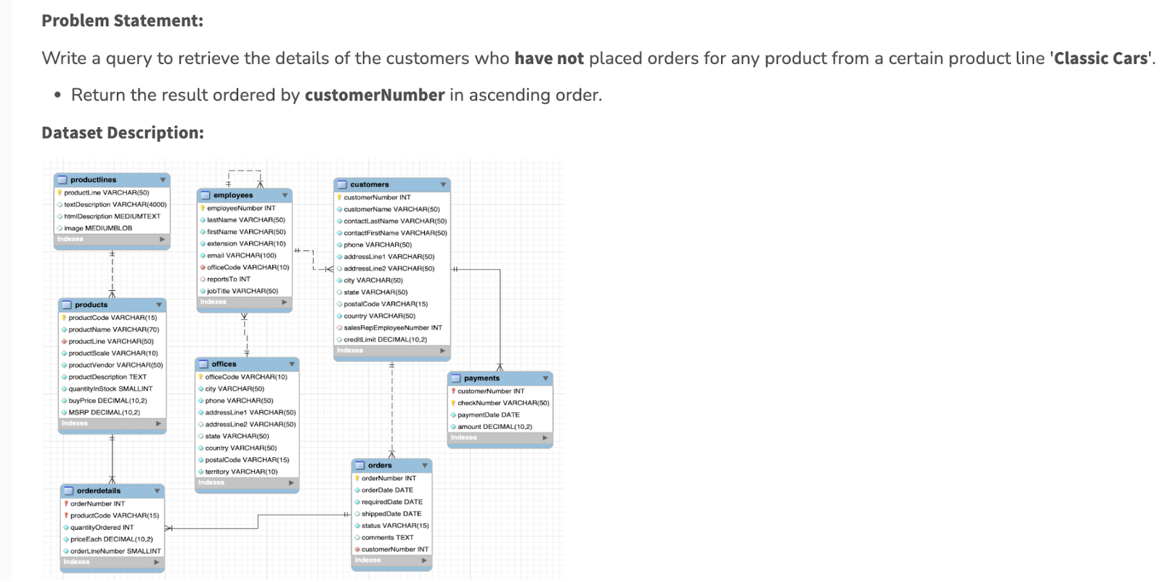

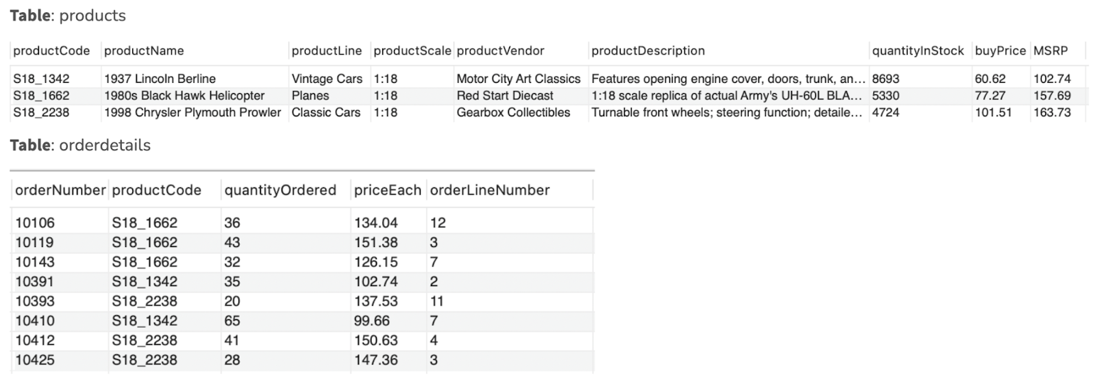

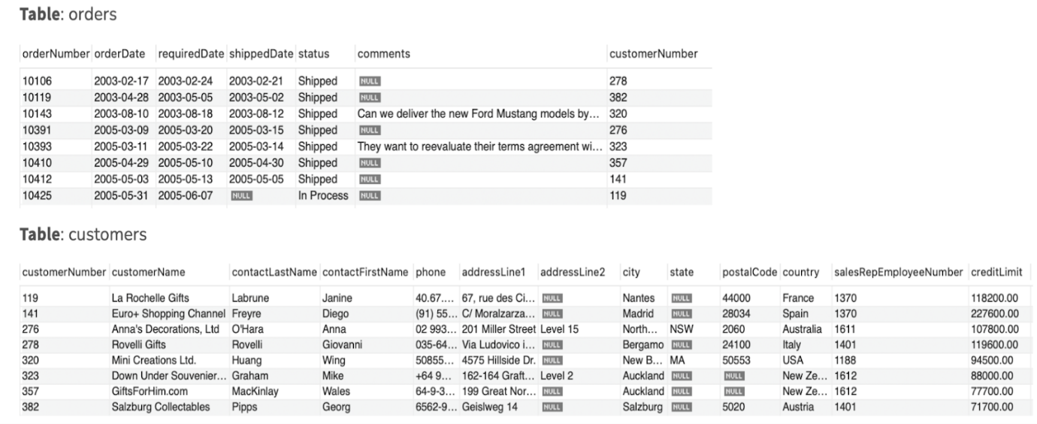

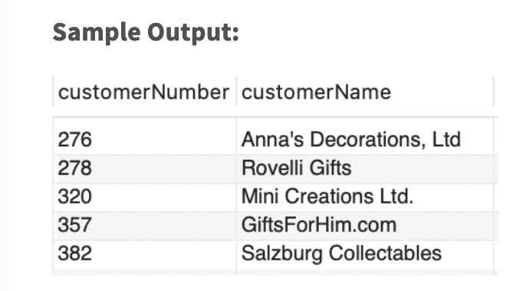

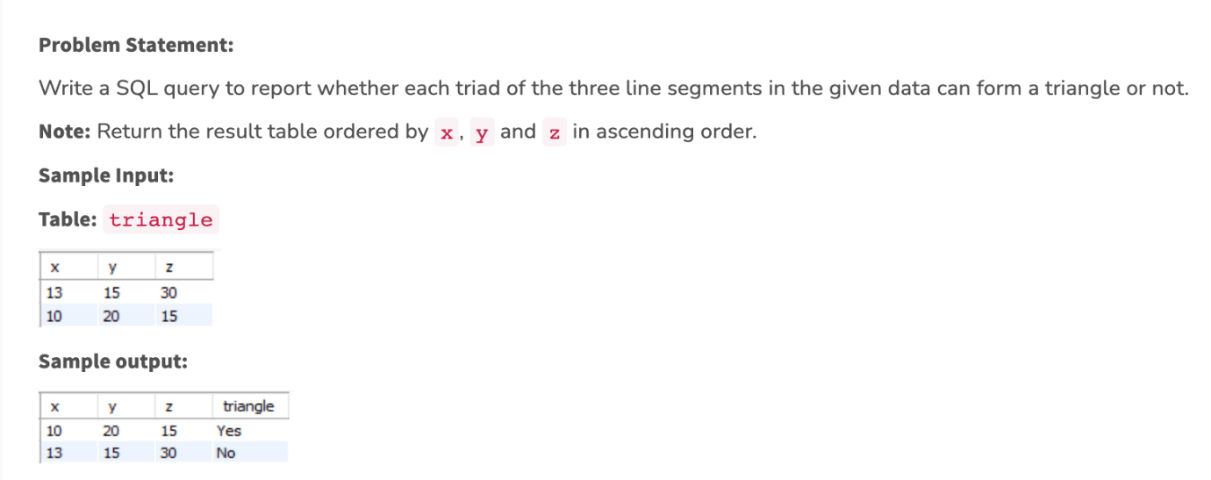

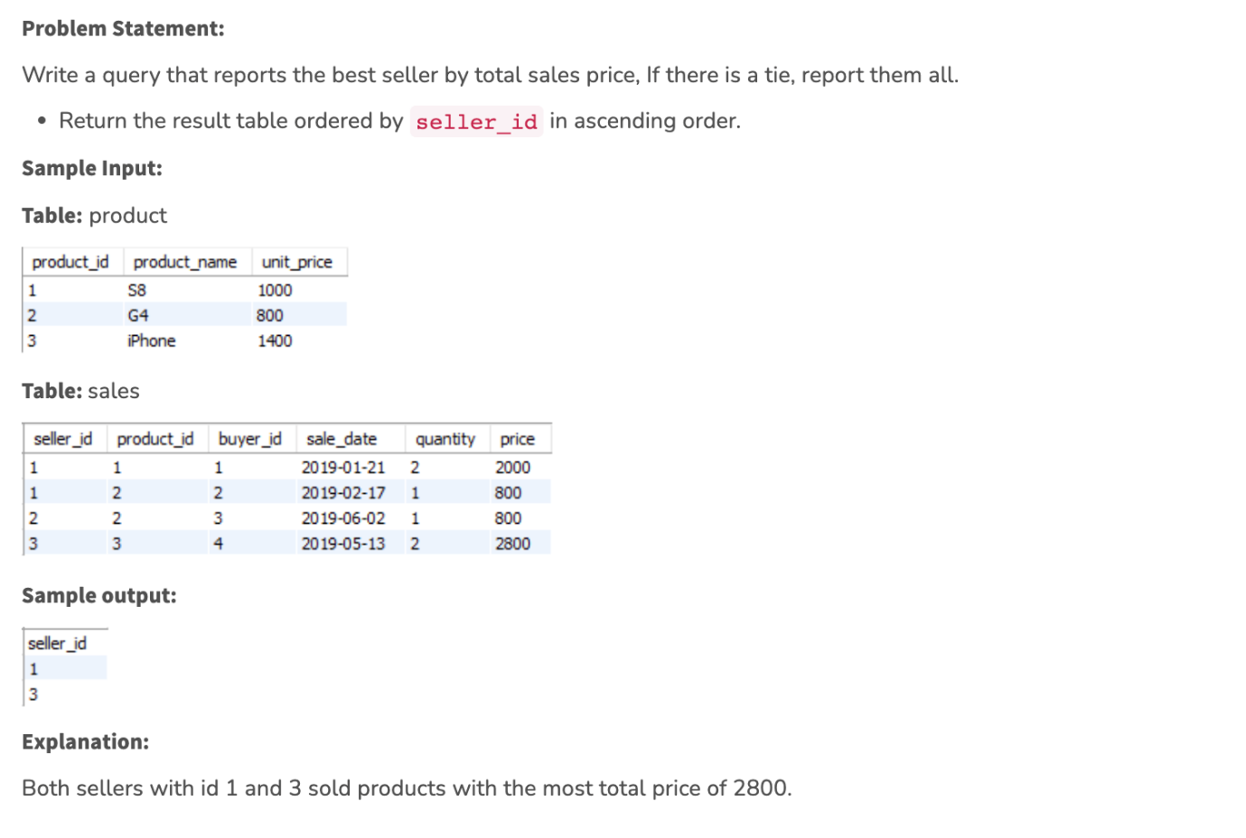

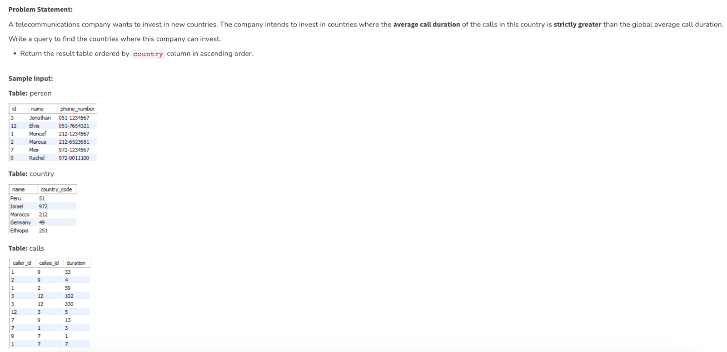

..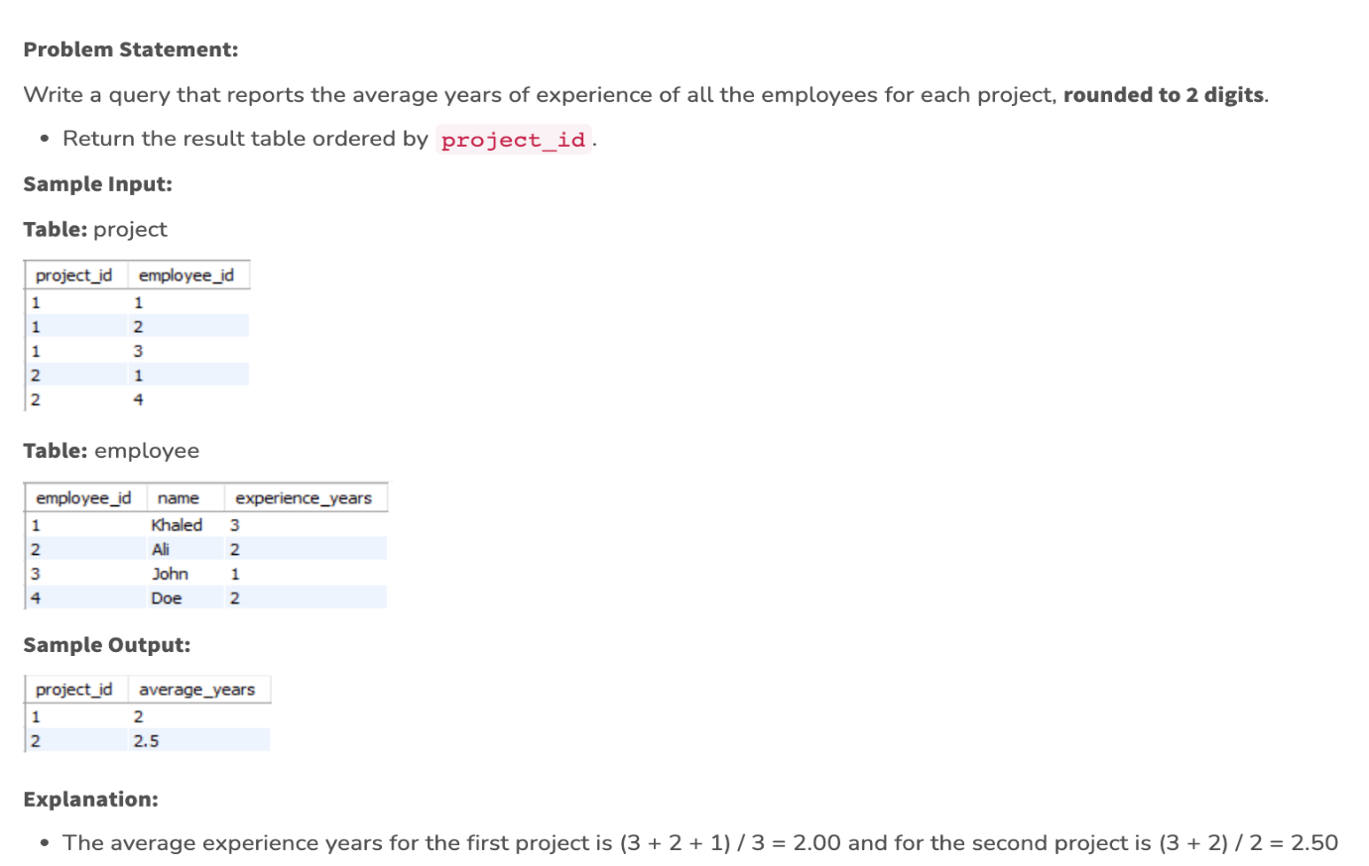

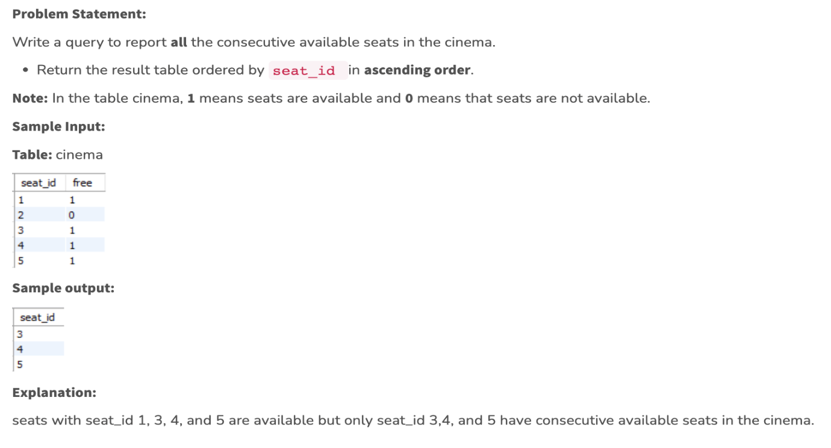

select * from (

select vendor_id, market_date, quantity ,

max(quantity) over (partition by vendor_id) as max_quantity

from `farmers_market.vendor_inventory`

) abc

where quantity = max_quantity

Last value of market date for each vendor and their max_quantity

select * from (

select *, row_number () over (partition by vendor_id order by market_date desc) as

row_num

from (

select vendor_id, market_date, quantity ,

max(quantity) over (partition by vendor_id) as max_quantity

from `farmers_market.vendor_inventory`

) abc

where quantity = max_quantity

)def

where row_num=1

—-----Window frames

select *, round(sum(sales) over (partition by customer_id order by market_date

rows unbounded preceding),2) as cum_sum from

(

select customer_id,market_date, sum(quantity*cost_to_customer_per_qty) as sales

from `farmers_market.customer_purchases_date`

group by 1,2

order by customer_id, market_date asc

)

Last 5 mov avg:

select *, round(sum(sales) over (partition by customer_id order by market_date

rows unbounded preceding),2) as cum_sum,

round(avg(sales) over (partition by customer_id order by market_date

rows 4 preceding), 2) as last5mov_Avg,

from

(

select customer_id,market_date, sum(quantity*cost_to_customer_per_qty) as sales

from `farmers_market.customer_purchases_date`

group by 1,2

order by customer_id, market_date asc

)

—----------- consolidated query—----

select *, round(sum(sales) over (partition by customer_id order by market_date

rows unbounded preceding),2) as cum_sum,

round(avg(sales) over (partition by customer_id order by market_date

rows 4 preceding), 2) as last5mov_Avg,

ntile(3) over (partition by customer_id order by market_date) as ntilerrr,

round(avg(sales) over (partition by customer_id order by market_date

rows between 4 preceding and 2 following), 2) as last4precand2followingmov_Avg,

from

(

select customer_id,market_date, sum(quantity*cost_to_customer_per_qty) as sales

from `farmers_market.customer_purchases_date`

group by 1,2

order by customer_id, market_date asc

)

where customer_id=20

—-----

select *, lead(sales, 1, 0) over (partition by customer_id order by market_date asc) as next_day_sales,

lag(sales, 1, 0) over (partition by customer_id order by market_date asc) as prev_day_sales,

first_value(value_expr)-------

from

(

select customer_id,market_date, round(sum(quantity*cost_to_customer_per_qty),2)as sales

from `farmers_market.customer_purchases_date`

where customer_id=20

group by 1,2

order by customer_id, market_date asc

)

—---------------------

Extracting from Timestamp

select market_start_datetime,

extract (day from market_start_datetime) as day,

extract (month from market_start_datetime) as month,

extract (year from market_start_datetime) as year,

extract (quarter from market_start_datetime) as quarter,

extract (week from market_start_datetime) as week,

extract (dayofweek from market_start_datetime) as quadayofweek,

extract (hour from market_start_datetime) as hour

from `farmers_market.datetime_demo`

—--------------

select (parse_datetime("%Y-%m-%d %H:%M:%S", timer_stamp)),

extract ( month from (parse_datetime("%Y-%m-%d %H:%M:%S", timer_stamp))) as month

from

( select market_date, transaction_time,

concat (market_date," ", transaction_time) as timer_stamp

from `farmers_market.customer_purchases`) abc

select parse_datetime("%Y-%m-%d %H:%M:%S","2019-07-13 08:58:00") as timer_stamp

—--

select market_start_datetime,

date_add(market_start_datetime, INTERVAL 15 DAY) as new_market_start_datetime,

date_add(market_start_datetime, INTERVAL 15 HOUR) as new_market_start_datetime_HOUR,

date_add(market_start_datetime, INTERVAL 30 MINUTE) as new_market_start_datetime_MINUTE,

date_add(market_start_datetime, INTERVAL -15 DAY) as new_market_start_datetime_sub,

date_sub(market_start_datetime, INTERVAL 15 DAY) as new_market_start_datetime_sub_1,

from `farmers_market.datetime_demo`

—------

**What does the query do? select extract(day from date), sum(sales) from tbl where date between current_date() and date_sub(current_date(), interval 60 days) group by extract(day from date)**

**—---**

**--Average time taken by a customer to come back/ Average Turn around time of the store**

**select avg(average) as TAT from (**

**select customer_id, sum(days_between)/count(days_between) as average from (**

**select *, date_diff(next_day,market_date, day) as days_between from (**

**select *,**

**lead(market_date,1 ) over (partition by customer_id order by market_date asc) as next_day**

**from (**

**select customer_id, market_date from `farmers_market.customer_purchases`**

**group by 1,2**

**order by customer_id asc, market_date asc) abc)**

**) base**

**group by 1**

**)**

**—--------- CTEs**

**with base as (**

**select a.*, b.vendor_name**

**from `farmers_market.customer_purchases` a**

**left join**

**`farmers_market.vendor` b**

**on a.vendor_id=b.vendor_id),**

**every_day_sales as (**

**select vendor_name, market_date, sum (quantity* cost_to_customer_per_qty) as sales from base**

**group by 1,2 )**

**select a.*, b.market_start_datetime from every_day_sales as a**

**inner join**

**`farmers_market.datetime_demo` b**

**on a.market_date=b.market_date**

**Policy for sharing projects?**

Many of the case studies in the Scaler DSML course are built in partnership with other companies. These partner companies have shared their datasets and problem statements with Scaler and, in doing so, they have given us a huge responsibility to keep their assets protected. Hence, we ask all students to sign an NDA in the beginning of the course.

At Scaler, we also understand that our students who work hard to solve these business cases would like to showcase their solutions on their Github, Kaggle, and Resume.

As such, here are the guidelines:

1. You may **not** post the Business Case Study problem statement anywhere.
2. You may **not** share any datasets anywhere, except for the publicly available datasets from Kaggle or public domain.
3. You may upload your solutions to your Github or Kaggle profiles as long as the solution:
4. does not contain any confidential information or intellectual property owned by the partner company or Scaler.
5. does not compromise Scaler’s confidentiality agreement with the partner company
6. does not compromise the NDA signed by the students
7. does not leak the shared datasets.
8. It is acceptable if small snippets or snapshots of the datasets may appear in your solution, as long as it does not compromise the overall privacy of the dataset, the partner company, or the stakeholders of the partner company.
9. You may list the project titles, a short description of the problem, and a short summary of your insights on your resume and on relevant platforms.
10. We recommend that instead of sharing the names of partner companies you use a generic description that makes you look professional. eg:
11. Instead of saying “worked on a project from Uber”, you can say “worked on a project from **a top ride-sharing company**”

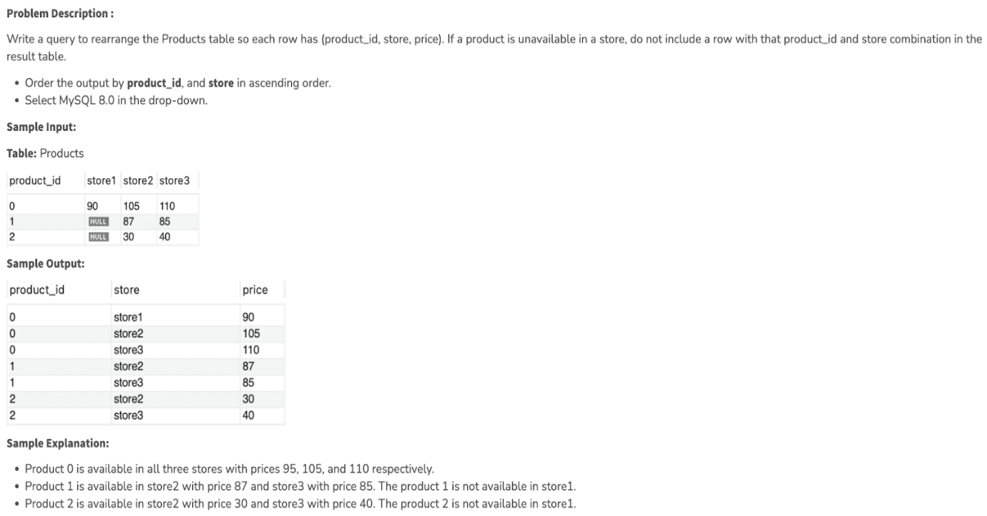

**—--------------------------**

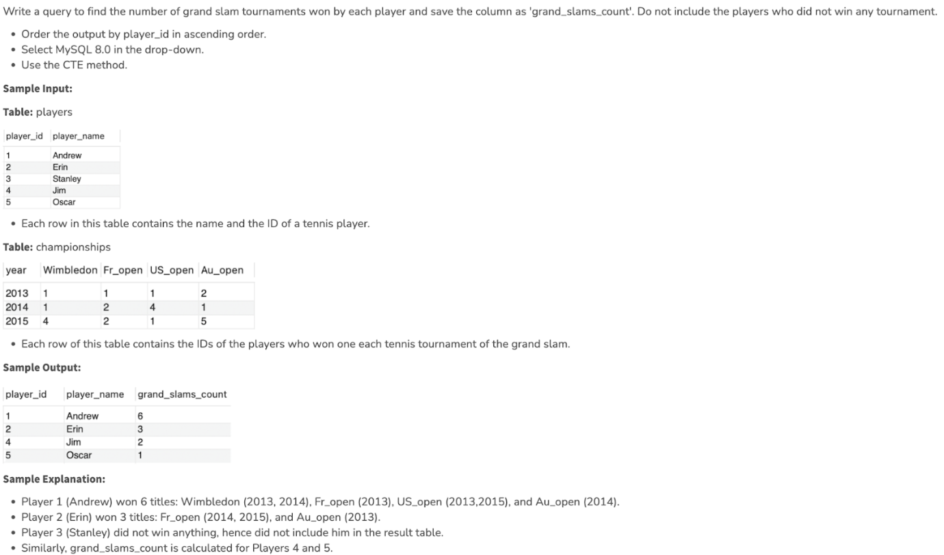

—--- MYSQL

create database hospital;

use  hospital;

Create table patients (patient_name varchar(30)

, phone int

);

select * from patients;

INSERT INTO patients VALUES ('HIMANSHU','997');

INSERT INTO patients VALUES ('Junaid','abc');

INSERT INTO patients VALUES ('Suraaj Hasija',9971840678);

alter table patients

modify phone varchar(30);

alter table patients

modify patient_name bigint;

alter table patients

rename COLUMN patient_name TO p_name;

alter table patients

ADD email varchar(30) unique;

INSERT INTO patients VALUES ('kuntal',8888888888, 'kuntal@scaler.com');

INSERT INTO patients VALUES ('kuntal1',8888888888, 'kuntal@scaler.com');

INSERT INTO patients VALUES ('kuntal1',8888888888, null );

Create table doctors (doctor_name varchar(30)

, phone int primary key

);

INSERT INTO doctors VALUES ('kuntal',null);

INSERT INTO doctors VALUES ('kuntal',889988999);

update patients

set email='himanshu@scaler.com'

where p_name='HIMANSHU';

RENAME TABLE patients to Patient;

#Delete from Patient where p_name='suraaj';

#TRUNCATE TABLE Patient;

#drop table patient;

—------------------

use hospital;

drop table bills;

create table bills (

patient_id INT NOT NULL,

    name varchar(40),

    bill_date Date primary key,

    amount decimal (8,2) not null)

    PARTITION BY RANGE (YEAR(bill_date))

(

        PARTITION P1 VALUES LESS THAN (2016),

        PARTITION P2 VALUES LESS THAN (2017),

         PARTITION P3 VALUES LESS THAN (2018),

          PARTITION P4 VALUES LESS THAN (2021))

          ;

  insert into bills values

  ( 1,'suraaj', '2015-02-10', 1000.2) ,

    ( 2,'suraaj1', '2016-02-10', 1980.2) ,

      ( 1,'suraaj2', '2017-02-10', 10300.2) ,

        ( 1,'suraaj3', '2019-02-10', 10200.2) ,

          ( 1,'suraaj4', '2018-02-10', 1500.2) ,

            ( 1,'suraaj5', '2019-03-10', 1600.2) ,

              ( 1,'suraaj6', '2020-02-10', 1700.2) ;

create table category (

category_id INT primary key ,           01-01, 01-02

    name varchar(40),

    bill_date Date not null,

    amount decimal (8,2) not null)

    PARTITION BY list(category_id)

(

        PARTITION cat1 VALUES in (0,1),

        PARTITION cat2 VALUES in (2),

         PARTITION cat3 VALUES in (3),

          PARTITION cat4 VALUES in (4));

insert into category values

  ( 0,'suraaj', '2015-02-10', 1000.2) ,

    ( 1,'suraaj1', '2016-02-10', 1980.2) ,

      ( 2,'suraaj2', '2017-02-10', 10300.2) ,

        ( 3,'suraaj3', '2019-02-10', 10200.2) ,

             ( 4,'suraaj3', '2019-02-10', 10200.2)   ;

#hashing

create table hashing (

category_id INT primary key ,

    name varchar(40),

    bill_date Date ,

    amount decimal (8,2))

    PARTITION BY hash(category_id)

partitions 5;

    insert into hashing values

  ( 0,'suraaj', '2015-02-10', 1000.2) ,

    ( 1,'suraaj1', '2016-02-10', 1980.2) ,

      ( 2,'suraaj2', '2017-02-10', 10300.2) ,

        ( 3,'suraaj3', '2019-02-10', 10200.2) ,

             ( 4,'suraaj3', '2019-02-10', 10200.2)  ,

                ( 5,'suraaj3', '2019-02-10', 10200.2),

                   ( 6,'suraaj3', '2019-02-10', 10200.2)   ,

                      ( 719,'suraaj3', '2019-02-10', 10200.2)   ,

                         ( 440,'suraaj3', '2019-02-10', 10200.2)   ,

                            ( 2209,'suraaj3', '2019-02-10', 10200.2)   ,

  ( 23,'suraaj3', '2019-02-10', 10200.2)   ,

          ( 15,'suraaj3', '2019-02-10', 10200.2)   ,

             ( 17,'suraaj3', '2019-02-10', 10200.2)   ,

                ( 65,'suraaj3', '2019-02-10', 10200.2)   ,

                   ( 08,'suraaj3', '2019-02-10', 10200.2)   ;

—----------

SELECT TABLE_NAME, PARTITION_NAME, TABLE_ROWS, AVG_ROW_LENGTH, DATA_LENGTH

FROM INFORMATION_SCHEMA.PARTITIONS

where table_schema='suraaj' and table_name='bills'

select * from bills where year(bill_date)=2016;

select * from category

SELECT TABLE_NAME, PARTITION_NAME, TABLE_ROWS, AVG_ROW_LENGTH, DATA_LENGTH

FROM INFORMATION_SCHEMA.PARTITIONS

where table_schema='suraaj' and table_name='category';

Select * from hashing;

SELECT TABLE_NAME, PARTITION_NAME, TABLE_ROWS, AVG_ROW_LENGTH, DATA_LENGTH

FROM INFORMATION_SCHEMA.PARTITIONS

where table_schema='suraaj' and table_name='hashing';

—--- INDEXING—-

select * from indexing;

explain select * from indexing where first_name='suraaj';

create index first_name_index on indexing(first_name);

explain select * from indexing where first_name='suraaj';

—----------

select Concat(firstname, ' ', lastname) as full_name, hiredate

from `cochin.employees`

where LOWER(title) like 'sales representative%'

—-------

select productid from `cochin.products` where unitsinstock < reorderlevel

—-----

#Find and display the details of customers who have placed more than 5 orders.

select c.customerid, c.contactname, c.companyname, c.phone, count(distinct orderid) as orders from `cochin.customers` c

inner join

`cochin.orders` o

on c.customerid=o.customerid

group by c.customerid,

having count(distinct orderid)>5

order by count(distinct orderid) desc

-------

select customerid,companyname,contactname,phone from cochin_traders.customers where customerid in (

select customerid from cochin_traders.orders group by customerid having count(orderid)> 5)

-------

**H/W**

An employee of ours (Margaret Peacock, EmployeeID 4) has the record of completing most orders. However, there are some customers who've never placed an order with her. Show such customers.

select

*

from `cochin.customers` c

inner join

(select

distinct customerid

from `cochin.orders`

where employeeid <> 4)abc

on abc.customerid=c.customerid

------

select orderid, count(*) as line_items

from `cochin.order_details`

group by 1

order by line_items desc

limit 10

------

select * from `cochin.products` limit 10

------------

select p.productname, abc.total_quantity from `cochin.products` p

inner join

(select productid, sum(quantity) as total_quantity

from `cochin.order_details`

group by 1

order by total_quantity desc

limit 5)abc

on p.productid=abc.productid

—-

with base as (

select

extract (year from o.orderdate) as year_,

extract (month from o.orderdate) as month_,

round(sum(od.quantity * od.unitprice),2) as revenue

from

`cochin.order_details` od

inner join

`cochin.orders` o

on od.orderid=o.orderid

group by 1,2

order by 1,2

),

base_2 as (

select *, lead(revenue, 1) over (partition by year_ order by month_ asc) as next_rev from base)

select *, round((next_rev-revenue)/revenue*100,2) as per_inc from base_2